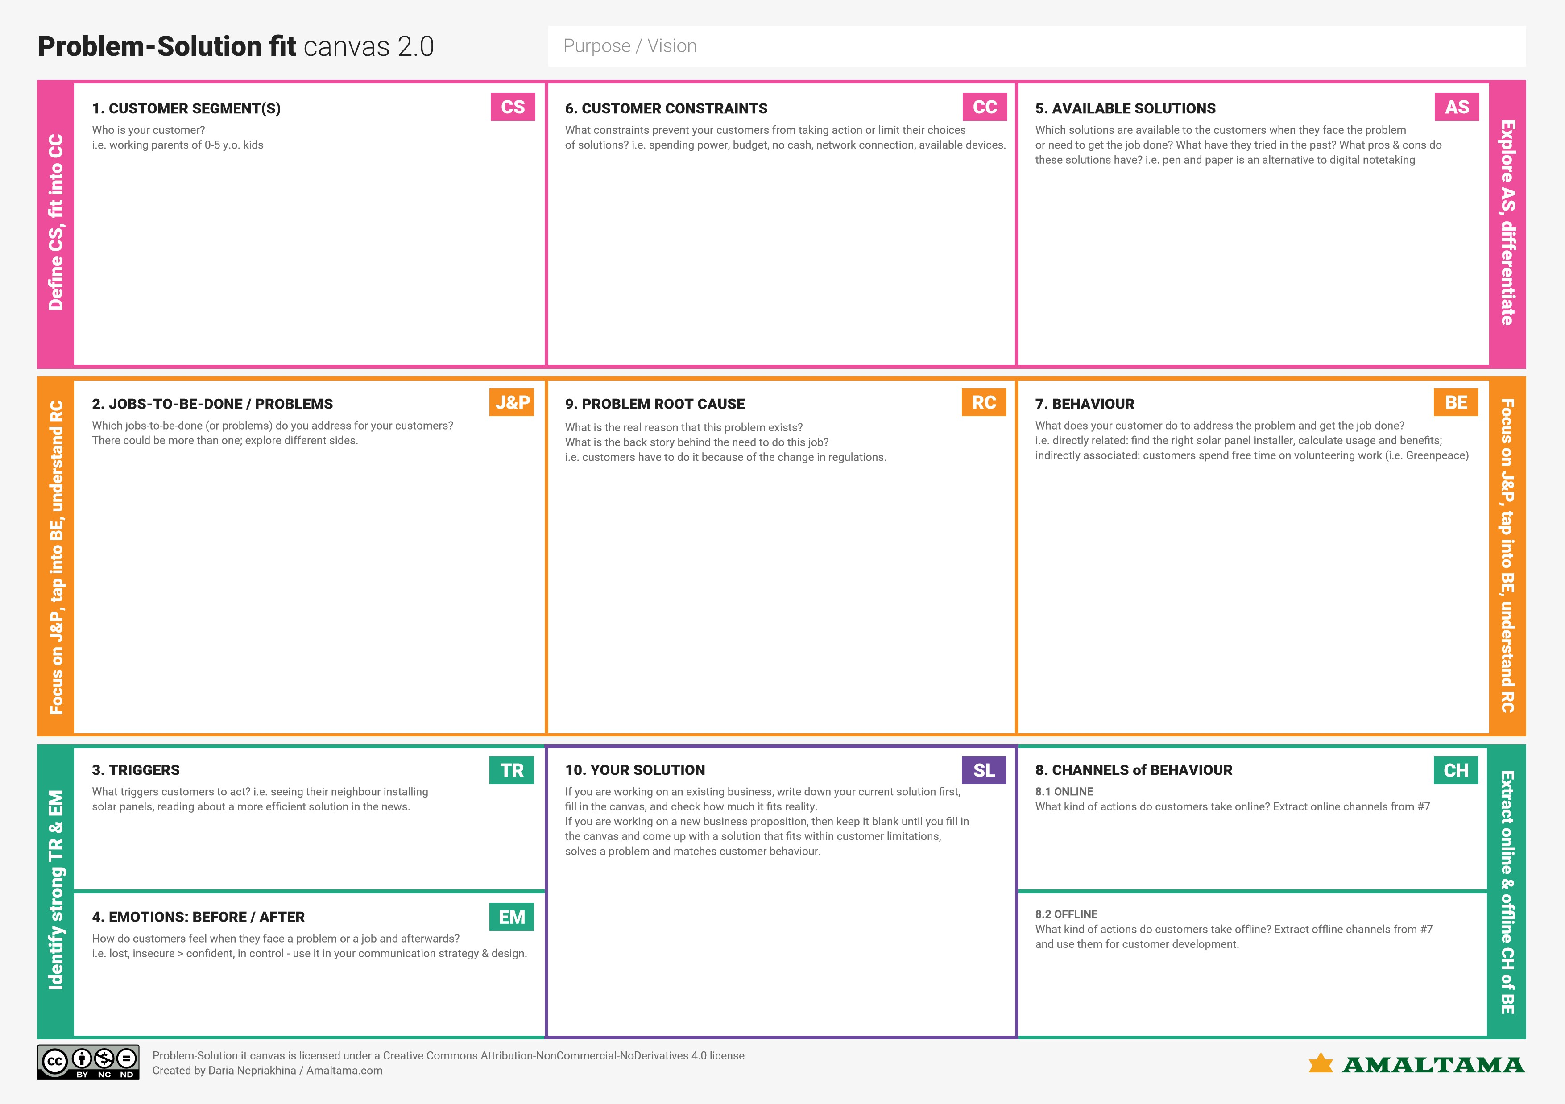

Even some parents opt caretakers to monitor their children ,so there is a possiblity of child getting harmed by the caretakers.

So our solution is to make IOT device which is affordable and user friendly for the parents

There are missing cases of children everywhere,so society is concerned about it.

Spending lots of money to the caretakers, parents might also lose their peace of mind in thinking about their child

Nowadays,there are working parents so it is difficult to monitor them continuously .

The children are misguided nowadays,so parents want them to be safe and monitored periodically.

CCTV and caretakers are the alternative solutions for monitoring the children

This is used by the parents who have child below 18 years.

keeping caretakers for monitoring the children.

Planning to install CCTV around the house or developing child tracker.

Children were not monitored properly before but now it made easy to monitor them